(GreenLK)

1. **Problems**
   * Facing technical issues
   * Readability Challenges
   * How design professional look web page
   * Not enough knowledge about Vuejs
2. **Solution Approach**
   * Explore tutorials on YouTube.
   * Watch day school recordings
   * Read blogs
3. **Architectural Diagram of the System**

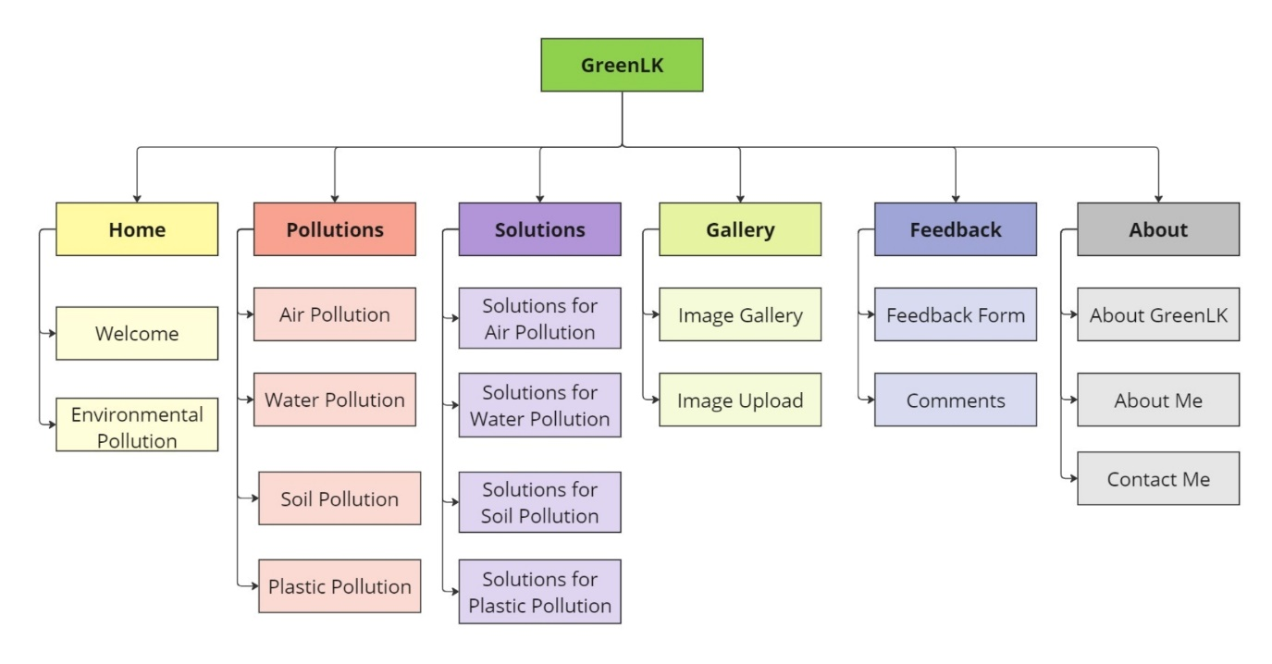

1. **Used Web Technologies and Examples**
   * Front End
     + HTML
     + CSS
     + JavaScript
   * Framework
     + VueJs (for feedback section)

**Examples**

**HTML**

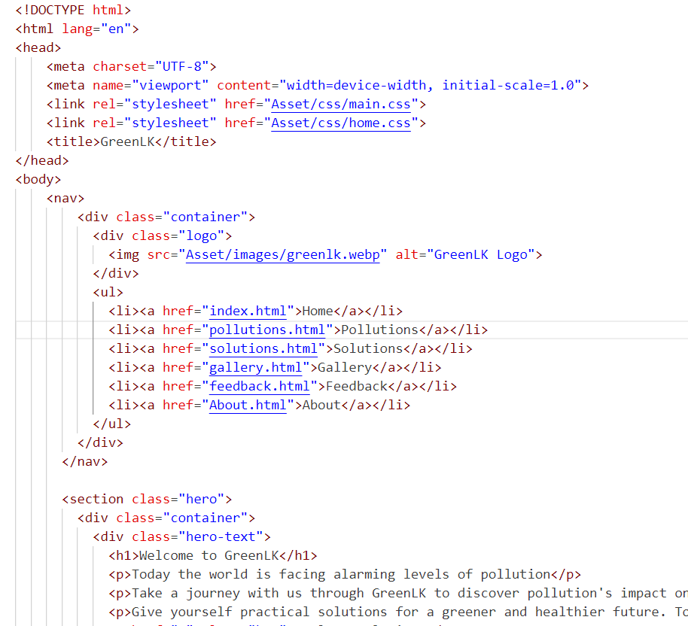

**CSS**

**JavaScript**

**VueJs**

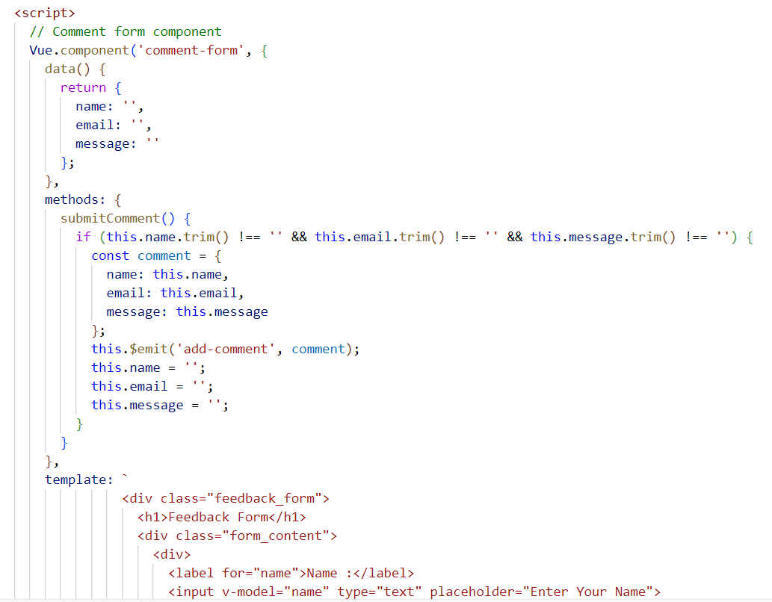

1. **Test Results**
2. **Conclusion**